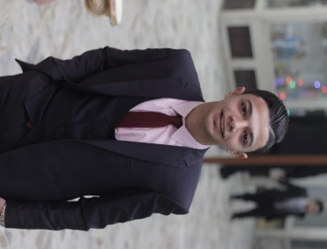**Name:** **Joseph Nagy William Azmy**

**Address:** 15 – NEW ELNOZHA

**Date of birth:**  28/04/2000  
**E-mail:** josephjolyo740@gmail.com

**Phone:** 01001405139--01274093290

**Education:**  College of Technology and Development

(Department Accounting)

**Grade:**

**Graduation Year:** Until studding

**Recruitment position:** Finished

**Objective:**

Pursuing a challenging career in a reputable organization that utilize my communication and language skills fulfils my personal ambitions and enhance my knowledge.

**Courses:**

* ICDL from CLS
* English from Cisco
* Drug Eye

**Experience:**

* Six years of experience in Sales – EL Oroby Company for Mobile Shop.
* Four years salesman – Karam Aziz’s Gold Shop.
* Financial and administrative accountant at ETF Company for Railways.

**Languages:**

* Arabic Fluent
* English Very Good

**Personal Skills:**

* Work hard under pressure and work in team work.
* Good at meeting deadlines and managing time to enhancing all at team work.
* Self-motivated, reliable and dynamic.

**My ambition:**

I Hope My C.V Will Agree Yours Requirement & I Will Have Great Pleasure If You Accept Me in Your Team.

Joseph Nagy