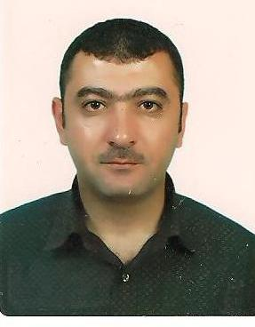

**Name** Talaat Salim Al Makt

**Address** 1- Imtan – As Suwayda-Damascus - Syria

2- Ashrafeya Sahnaya – Damascus - Syria

**Telephone** Mob : +963 994460586 , Home : +96316762185

**E-mail** emtany1974@yahoo.com

**Date of birth** 1st Oct 1974

**Nationality** Syrian

**Gender** Male

**Marital status** Married

**Education/Qualifications**

1994-1996 Al Mazra'a Agriculture institute with 71% degree ( Good Grade) .

Diploma *certificate*  in Horticulture.

**Employment to Date/Work Experience**

2017-present *Assistant engineer in agriculture ministry* .

2011-2013 Senior Store Manager in Tema retail - Egypt ( LCWaikiki ) Brand .

Store Manager Tema Textile (LCWaikiki Brand) – Aleppo – Syria

2010-2011 Brand Manager in United fashion Company- Tripoli – Libya ( Next ) Brand .

2009-2010 Store Manager in Senwan Retail Company- Tripoli- Libya ( Okaidi ) Brand.

2000-2009 Store Manager in Al shaya International Company ( Mothrecare Brand ) - Ksa.

Assistant Store Manager ( Next Brand ) Qatar.

Assistant Store Manager (Mothercare Brand ) Qatar.

Assistant Store Manager (Mothercare Brand ) Medina – Ksa (Saudi Arabia)

Sales Advisor ( Mothercare Brand ) Jeddah – Ksa ( Saudi Arabia ) .

**Other Experience/Activities**

2005-2013 Manage store contribution through maximizing every opportunity to drive sales, reduce stock loss and maintain cost controls. In-charge in delivering the highest levels of motivation and development of team members and individual and store compliance with the all TAF standard and procedures.

2000-2005 Received ‘ABCD’ award for excellent customer service.

Given responsibility to look after all the departments as well as visual display.

Given responsibility to be the in-charge of the store in absence of Manager.

Proved to be a team leader by improving self effectiveness.

**Languages** Arabic : Mother tongue , English: near native speaker ( Excellent ) .

**Other Skills** Computer literate: Windows applications, Office Programs , Mailing, translate.

**Interests** Travelling, international affairs, meeting friends, Reading , challenging .

**References** - Mr. Erkan Bayrak (OPS-Tema Retail EG)-Turkey

Tel: +905308288776 [Erkan.Bayrak@lcwaikiki.com](mailto:Erkan.Bayrak@lcwaikiki.com)

- Mr.Abdullah Al Mamun(OPS-Alshaya int.Co-KSA)

Tel: +966503123804 [mamun@alshayaksa.com](mailto:mamun@alshayaksa.com)